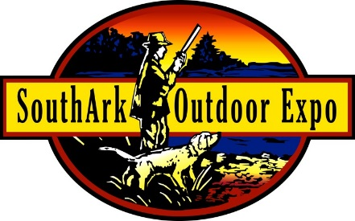
SouthArk Outdoor Expo
2014 Rib Cook-off Contest Entry Form
sponsored by
Herring Furniture/Holland Grill

Team Name

Company Sponsor Head Cook

Email Address Email Address

Address Address

City State Zip City State Zip

Phone Phone

Date: Saturday, September 13, 2014, 8:00 a.m.--5:00 p.m. Cooking Time: 8:00 a.m.--2:00 p.m.
Location: El Dorado Conference Center, 311 S. West Ave., El Dorado, AR
Set-up: September 12, 10:00 a.m.--5:00 p.m. Set-up Location: S. Washington St. between Locust and Pony St.

Registration Deadline: Wednesday, September 3, 2014, but sooner is better!

I will cook at least six racks of ribs.

Yes No

I will bring a generator for my own use.

Yes No

Total number of racks you can cook? Size of space needed:

Contestant agrees to indemnify and hold SouthArk Foundation, Inc. Outdoor Expo, its employees and volunteers harmless from any and all claims made against the Outdoor Expo, including without limitation, all costs, liabilities, judgments, expenses, damages, and attorneys’ fees, arising out of or in connection with (1) any structure erected by entrant, (2) any apparatus, equipment, or personal property used by entrant, (3) any act or omission to act of entrant, its agents, invitees, participants, representatives, employees, servants, and agents, and (4) any claims made on account or resulting from entrant’s participation in the contest. Any photos taken by the Outdoor Expo of your team/equipment becomes our property.

I will enter and be judged in the competitions selected below. (Entry fee must be paid; other competition entries are optional).

Rib Cook-off Entry Fee $100 Cooker's Choice (additional $25) Best Team Spirit (additional $10)

I have read and agree to the SouthArk Outdoor Expo Cook-off rules YES

For more information, email foundation@southark.edu or call 870/864.7130

Complete rules can be downloaded from www.southarkexpo.com

